Seal Point Siamese Cat Club
Hon Secretary  Ms Denise Burgess  7 Denning Close  Maidstone  Kent, ME16 0WT  E:tansyrex@btinternet.com | Chairman:  Mrs Yvonne Marriott  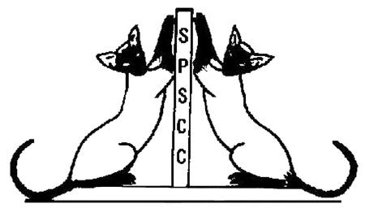 | Hon Treasurer  Drs Mike & Jane Alexander  Rectory Cottage  Ridings Way, Cubblington  Bucks, LU7 0LW  E: janea2000@aol.com

Application for Membership

Name (Mr, Mrs, Miss, Ms) ..............................................................................

Address ..........................................................................................................

..........................................................................................................

Postcode ..........................................................................................................

Tel.No. ..........................................................................................................
Email: ………………………………………………………………………….....

Prefix ...........................................................................................................

Proposer ..........................................................................................................
(Must be a member of the SPSCC)

Applicants for Membership should enclose their subscription and entry fee to the Hon Secretary – Drs Mike and Jane Alexander

SINGLE SUBSCRIPTION: £5.00
JOINT SUBSCRIPTION: £8.00
ENTRY FEE PER PERSON: £1.00
SINGLE LIFE MEMBERSHIP: £35.00
JOINT LIFE MEMBERSHIP: £50.00
SENIOR CITIZEN LIFE MEMBERSHIP: £25.00
FOREIGN SUBSCRIPTION: £25.00

Rule book will be issued to new members on acceptance

